can we construct monolithic application using Client server style
Yes, a monolithic application can be constructed using a client-server style. The terms are not mutually exclusive but describe different levels of architectural organization. While "monolithic" defines how the server-side is built, "client-server" describes how the application is distributed across a network.
Here is how they fit together:
- The server is the monolith: In this model, all the server-side functions are built into a single, unified, and tightly-coupled application. This single server application handles all requests from clients, executes all business logic, and interacts with the database.
- The client is separate: The client, such as a web browser or a mobile app, runs separately on the user's device and communicates with the single monolithic server over a network.
- Network communication: The client sends requests to the server, and the server processes the requests and sends back the necessary data or a formatted web page.
Architectural tiers
The combination of a monolithic server with a separate client is a traditional and common architectural model, often referred to as a two-tier or three-tier architecture, depending on how the database is counted.
- Three-tier client-server: The client communicates with the application server (the monolith), which then communicates with a separate database server. The monolithic server still holds all the business logic, but the data storage is handled by a separate process.
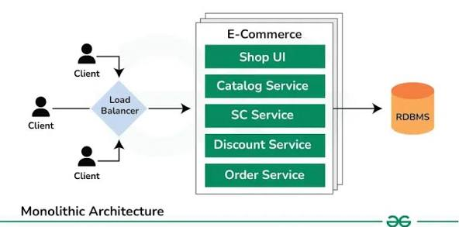

Examples of monolithic client-server applications
- Traditional web applications: Many early and modern websites were built this way. A single server application (often a single WAR file in Java or a Flask app in Python) generates and serves all the web pages. The client is the user's web browser.
- Early e-commerce platforms: A business might start with a monolithic server that handles the product catalog, user accounts, shopping cart, and payment processing. The client is the front-end interface, which requests information from the server to display pages.
- Desktop applications: Some traditional desktop applications connect to a single, proprietary backend server to access centralized data. All server-side business logic and data processing occur within that single server application.
Key takeaway
A monolithic application is defined by its single, unified codebase, while a client-server style is defined by the separation of the user interface (the client) from the data and logic (the server). Since a server can be constructed as a single, large application, these two concepts can and frequently do coexist.
In a client-server style monolithic application, the client is a separate user interface, while the entire business logic and data access run as a single, tightly-coupled unit on the server
This can be visualized as a three-tier architecture:
- Presentation Tier (Client): The user interface, such as a web browser or mobile app, that initiates requests.
- Application Tier (Monolithic Server): A single application that contains all the code for the business logic, services, and data access.
- Data Tier (Database): A relational database that the monolithic application interacts with.
Here is a diagram representing this architecture:
Diagram of a client-server monolithic application
Draw by yourself
How the components interact
- Client Request: A user interacts with the client (e.g., a web browser). The client sends a request over the network (Internet or LAN) to the monolithic server.
- Monolithic Server: The server-side application receives the request. Because it is a monolith, this one application contains everything needed to process the request, including:
  - Presentation Logic: The code that generates the HTML pages (or other UI elements) to send back to the client.
  - Business Logic: The core functionality, such as processing e-commerce purchases or managing user profiles.
  - Data Access Layer: The code that interacts with the database.
- Database Interaction: The monolithic server connects to and queries the database to retrieve or store necessary data.
- Server Response: The monolithic server, after processing the request and potentially fetching data from the database, sends a response back to the client.
- Client Display: The client receives the response and displays the information to the user.
This architecture is distinct from a microservices approach, where the server-side business logic would be broken down into many independent, smaller services, instead of a single monolith.
Can we construct microservice application using Client server style
Yes, a microservices application is inherently constructed using a client-server style. In a microservice architecture, the "server" is not a single, monolithic application but a collection of multiple, independently developed and deployed services. Clients then communicate with these individual services.
The key difference from a traditional monolithic client-server model is the nature of the server side:
- Server-side is decomposed: The business logic is not in one large application but is split into many smaller, specialized microservices.
- Clients interact differently: Instead of talking to a single server, clients may communicate with many different services. This is typically managed through an API Gateway, which acts as a single entry point for all client requests. The API Gateway then routes the requests to the correct internal microservice.
Diagram of a microservices client-server application
Draw by yourself
How the components interact
- Client Request: A client sends a request to a single, well-known endpoint, the API Gateway.
- API Gateway Routing: The API Gateway receives the request and, based on the request path, routes it to the appropriate microservice. For example, api.example.com/products might be routed to the Products service, while api.example.com/users is sent to the Users service.
- Microservice Execution: The designated microservice executes its specific business logic. Each microservice manages its own data and does not directly access another service's database. A microservice might call other internal microservices to fulfill the request.
- Database Interaction: The microservice interacts with its own, private database. This decentralization of data is a key characteristic of a microservices architecture.
- Service Response: The microservice sends its response back to the API Gateway. The API Gateway then aggregates results (if needed) and sends the final response to the client.
Key takeaways
- Yes, microservices use a client-server style. The client is separated from the server.
- The server is not a single entity. It is a collection of independent services that coordinate with each other.
- The API Gateway is often the public face of the server-side. It simplifies the client's view of a complex, distributed system.
3 Tiers in a microservice architecture
1. Presentation Tier (Client)
This is the user interface that the end-user interacts with. It can be a web browser, a mobile application, or a desktop app. The client-side logic is kept thin and stateless, focusing on displaying data and handling user input.
- Role in microservices: The client is completely decoupled from the back-end services. It only communicates with a single entry point, typically an API Gateway. This provides a clean separation of concerns and prevents the client from needing to know about the internal complexity of the microservice architecture.
2. Application Tier (Middle/Logic)
In a traditional three-tier architecture, this tier is a single application. In a microservice architecture, this tier is where the distribution really happens. The single application is replaced by a collection of independent, specialized microservices.
- Role in microservices:
  - API Gateway: This acts as the facade for the microservices. It handles routing client requests to the correct internal microservice, aggregates responses, and can perform other cross-cutting functions like authentication, rate limiting, and load balancing.
  - Independent Microservices: Each service within this tier is responsible for a specific business capability, such as a "product catalog service," an "order service," or a "payment service". These services can be written in different languages and managed by different teams (polyglot).
3. Data Tier (Storage)
In a traditional three-tier model, there is a single, centralized database. In a microservice architecture, this tier is decentralized to support the independent nature of the services.
- Role in microservices:
  - Decentralized Data: A core tenet of microservices is that each service owns its own data. This means that instead of one central database, there are multiple databases, with each one tied to a specific microservice.
  - Polyglot Persistence: Microservices can use different types of databases (SQL, NoSQL, etc.) based on their specific needs. For example, a "user profile" service might use a fast key-value store, while an "order history" service uses a traditional relational database.
How it all works together
A request from the client moves through the architecture as follows:
- Client request: A user interacts with the Presentation Tier (e.g., a web browser) and sends a request.
- API Gateway: The request first hits the Application Tier at the API Gateway.
- Service routing: The API Gateway identifies the correct microservice based on the request.
- Business logic: The microservice processes the request using its own internal business logic.
- Data access: The microservice accesses its own dedicated database in the Data Tier.
- Service response: The microservice sends a response back to the API Gateway.
- Final response: The API Gateway sends the final, formatted response to the client.
This approach offers benefits like independent scalability, greater fault isolation, and the ability to use the best technology for each individual service.

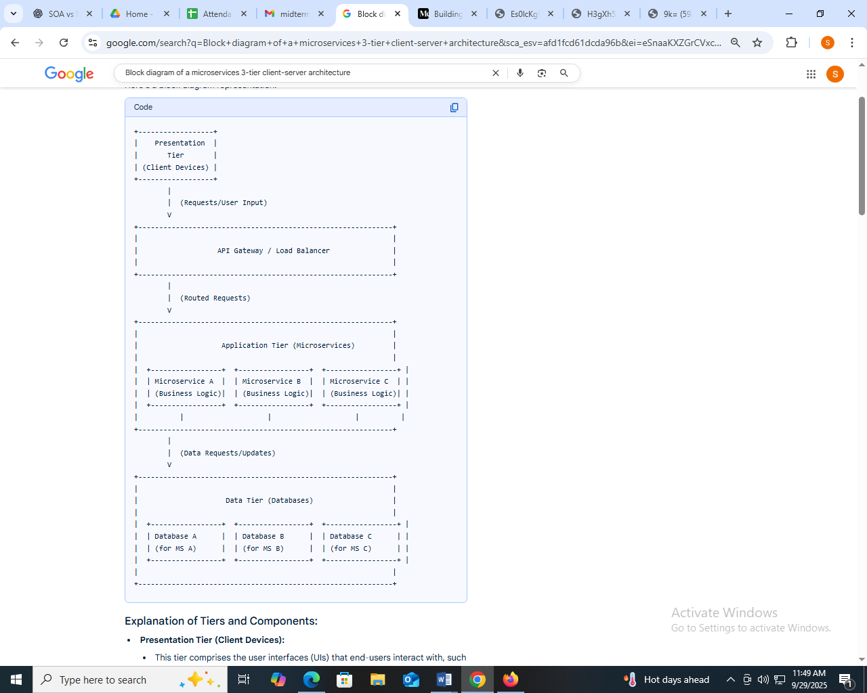
Explanation of Tiers and Components:
- Presentation Tier (Client Devices):
  - This tier comprises the user interfaces (UIs) that end-users interact with, such as web browsers, mobile applications, or desktop clients.
  - It handles user input, displays information, and communicates with the application tier.
- API Gateway / Load Balancer:
  - Acts as the single entry point for all client requests into the microservices architecture.
  - Routes incoming requests to the appropriate microservice based on defined rules (e.g., URL paths, headers).
  - Provides features like load balancing, authentication/authorization, rate limiting, and caching.
- Application Tier (Microservices):
  - This is the core of the architecture, consisting of a collection of independent, loosely coupled microservices.
  - Each microservice encapsulates a specific business capability and can be developed, deployed, and scaled independently.
  - Microservices communicate with each other through lightweight mechanisms like RESTful APIs or message queues.
- Data Tier (Databases):
  - This tier stores and manages the data required by the application.
  - In a microservices architecture, each microservice typically owns its own data store (e.g., Database A for Microservice A), promoting data independence and enabling different database technologies to be used for different services if needed.
E-commerce example microservice+3 tier

Explanation of Tiers and Components:
1. Client Tier (Presentation Layer):
- Web Browser / Mobile App:
This represents the user interface where customers interact with the e-commerce platform. It could be a web application accessed via a browser or a native mobile application.
- Frontend Frameworks / Mobile SDKs:
Technologies like React, Angular, Vue.js for web, or platform-specific SDKs for mobile, are used to build the interactive user interface and handle client-side logic.
2. Application Tier (Business Logic Layer - Microservices):
- API Gateway:
This acts as a single entry point for all client requests. It handles routing requests to the appropriate microservice, authentication, rate limiting, and potentially load balancing.
- Authentication Service:
Manages user registration, login, and token-based authentication (e.g., JWT, OAuth2).
- Product Catalog Service:
Handles all operations related to products, including listing, searching, retrieving product details, and managing inventory.
- Shopping Cart Service:
Manages the state of a user's shopping cart, allowing items to be added, removed, and quantities updated.
- Order Management Service:
Processes orders, handles order status updates, and manages order fulfillment.
- Payment Service:
Integrates with external payment gateways to process transactions securely.
- User Profile Service:
Manages user-specific information, such as addresses, order history, and preferences.
- Message Broker (e.g., Kafka, RabbitMQ):
Facilitates asynchronous communication between microservices, enabling loose coupling and event-driven architectures. This is crucial for handling events like order creation, payment confirmation, or inventory updates across different services.
3. Data Tier (Data Storage Layer):
- Product Database:
Stores product information, categories, images, and inventory levels (e.g., PostgreSQL, MongoDB).
- Cart Database:
Stores temporary shopping cart data, often using in-memory databases for speed (e.g., Redis).
- Order Database:
Stores order details, customer information, and payment status (e.g., MySQL, Cassandra).
- Payment Gateway Integration:
Represents the secure connection and interaction with third-party payment processing services.
- User Database:
Stores user account details, credentials, and profile information (e.g., PostgreSQL).
E-commerce example monolithic +3 tier
Explanation of Tiers:
- Client Tier (Presentation Layer):
  - User Browser/Mobile App: This represents the user's device, which could be a web browser accessing a website or a native mobile application.
  - User Interface (HTML, CSS, JS): This is the front-end of the e-commerce application, responsible for displaying information to the user and capturing user input. It handles the visual presentation and client-side interactions.
- Application Tier (Business Logic Layer):
  - Web Server (e.g., Nginx, Apache): This acts as the entry point for client requests, routing them to the appropriate application server. It can also handle static file serving and load balancing.
  - Application Server (e.g., Node.js, Java Spring, Python Django): This is the core of the monolithic application, containing all the business logic and functionalities of the e-commerce platform.
  - Business Logic (Product Catalog, Order Management, User Authentication, Payment Processing): This encompasses all the rules and processes that govern the e-commerce operations, such as managing products, processing orders, authenticating users, and handling payments.
  - Data Access Layer (ORM, Database Drivers): This component is responsible for interacting with the database, abstracting the underlying database technology from the business logic. It handles data retrieval, storage, and manipulation.
- Data Tier (Data Layer):
  - Database (e.g., MySQL, PostgreSQL, MongoDB): This is where all the application's data is stored and managed, including product information, user profiles, order details, and payment records.
Flow of Interaction:
- A user interacts with the User Interface in their browser or mobile app.
- The User Interface sends requests to the Web Server.
- The Web Server forwards these requests to the Application Server.
- The Application Server executes the relevant Business Logic and uses the Data Access Layer to interact with the Database.
- The Database stores or retrieves the necessary data.
- The Application Server processes the data and sends a response back to the Web Server.
- The Web Server then sends the response to the User Interface, which updates the user's view.

